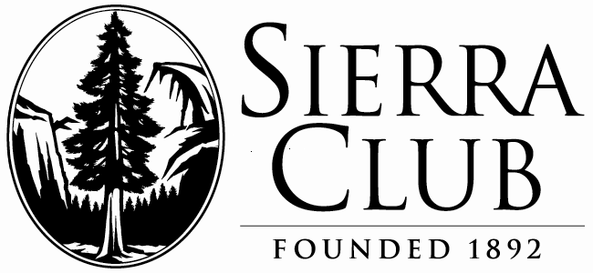July 20, 2011

Ohio Sierra Club

131 North High Street, Suite 605

Columbus, OH 43215-3026

614-461-0734

Dr. Steven Chu

Secretary of Energy

U.S. Department of Energy

1000 Independence Avenue, S.W.

Washington, DC 20585

Dear Dr. Chu:

On June 11, 2011, six centrifuges at the USEC, Inc. American Centrifuge Project at Piketon, Ohio, were damaged by a power outage. Both the main and auxiliary power systems failed, with subsequent disabling of ventilation and hydrogen monitors in a battery room. As you are aware, hydrogen buildup and subsequent fire are a serious hazard in the present, but catastrophic should this occur with a full enrichment process in operation.

Clearly, further safety evaluations of the plant are essential. With this letter, we are asking the Nuclear Regulatory Commission (NRC) to investigate this situation and to implement the recommendations of its Japan Task Force at Piketon.

This incident increases the Sierra Club’s, as well as the public’s, conviction that serious problems exist with the plant’s enrichment technology. It also calls attention to the need for thorough safety and evacuation reviews. The local community must be assured that a fire or explosion in an operating centrifuge plant would not cause radioactive or hazardous material to escape outside the buildings.

The Department of Energy must not consider a $2 billion loan guarantee to USEC, Inc. without at the very least a thorough safety study by the NRC, including assurance that the centrifuge buildings are sufficiently hardened.

The timing of the reporting of the June 11 incident, 19 days after the fact, is under investigation and is also cause for concern.

On August 4, 2009, after discussions with USEC, Inc., the Department of Energy agreed to delay final review of USEC, Inc.’s loan guarantee application pending resolution of the financial and technical issues identified. After two years, USEC, Inc. appears to be a long way from resolving their technical issues. They also have serious financial problems, high expenses and increasing competition in a fixed market.

The Ohio Sierra Club wishes to convey that approval of a $2-billion loan guarantee without resolution of these issues would be tantamount to a giveaway of public money and a serious violation of the public trust.

Sincerely,

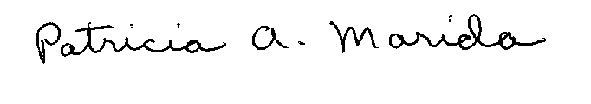

Patricia A. Marida, chair Robert Shields, chair

Ohio Sierra Club Nuclear Issues Committee Ohio Sierra Club

Cc: NRC Chairman Gregory Jaczko

Governor John Kasich

Senator Sherrod Brown

Senator Rob Portman

Ohio Congressional Representatives and Statehouse Legislators